CS 340 README Template

About the Project/Fetch&Rescue
Fetch&Rescue is a reusable Python module designed to support Grazioso Salvare’s mission to identify and categorize canine candidates for search-and-rescue training. By providing a robust, streamlined CRUD interface for MongoDB, the module enables operators to efficiently manage, query, and analyze canine candidate profiles, thereby streamlining the recruitment process. Additionally, the client-facing web application dashboard provides a user-friendly interface for interacting with and visualizing database data, reducing user errors and training time.

Motivation
Animal shelters are overflowing with dogs in need of homes, while search-and-rescue organizations desperately need capable animals. Manually sifting through hundreds of shelter records to find a suitable dog with the right breed, age, and behavior is time-consuming and inefficient. Fetch&Rescue was created to bridge this gap. The shelter data will be used to accelerate the recruitment pipeline, making candidate matching faster and more accurate. The application directly helps rescue more shelter dogs and deploy more highly trained animals to emergencies.

Getting Started
To get a local copy up and running, follow these simple example steps:
- Open MongoDB and switch to the datasets directory
- Import the csv file containing the data set: aac_shelter_outvome.csv
  - Use the database name “aac” and collection name “animals.”
  - Ex) mongoimport --type=csv --headerline --db aac --collection animals --drop ./aac_shelter_outcomes.csv
  - If the import was successful, the terminal should report back “imported successfully.”
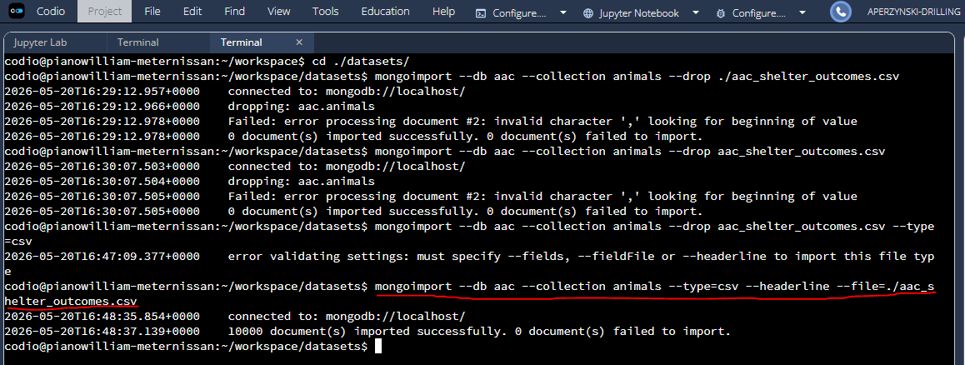
- Create a simple index on the key “breed.”
  - Use the “aac” database
  - Ex) db.animals.createIndex({breed : 1})
- Create a compound index for “outcome_type” of “Transfer.”
  - Ex) db.animals.createIndex({breed : 1, outcome_type : 1})
- Check that each index was created successfully using the command: db.animals.getIndexes()
  - Ex)
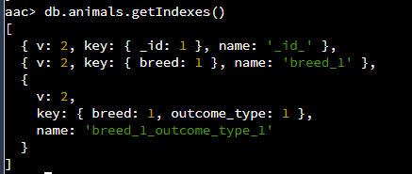
- If the administrator account does not exist, configure one now.
  - See Create a User on Self-Managed Deployments for more detailed instructions.
- Create a new user account called “aacuser” with read and write access to the database “aac” in the default “admin” authentication database
  - Ex) db.createUser( { user: "aacuser", pwd: passwordPrompt(), roles: [ { role: "readWrite", db: "aac" } ] } )

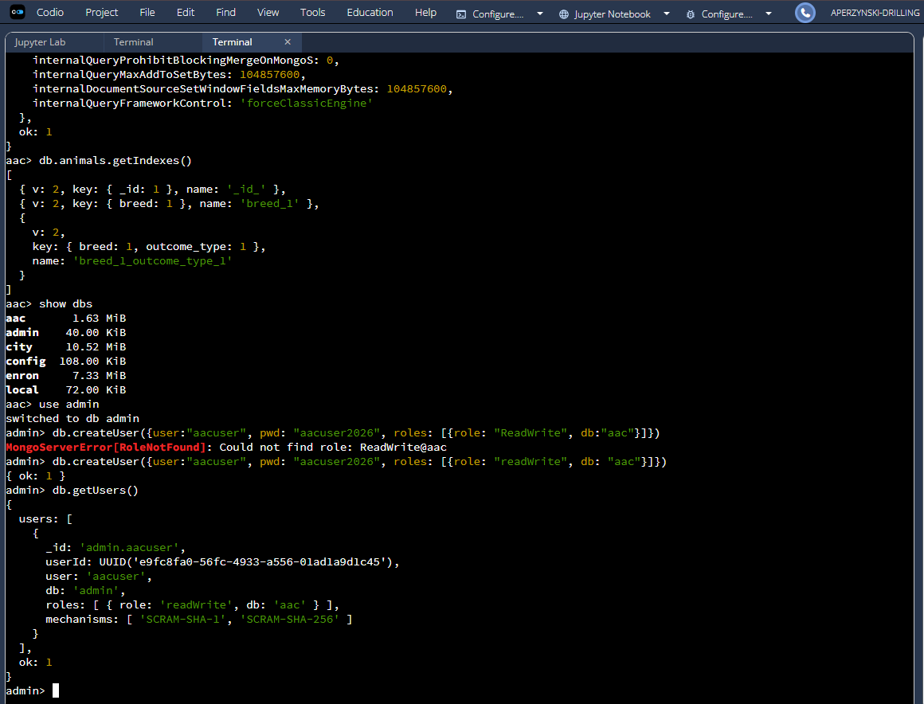
  - Log in with the user account to verify it is working as expected.

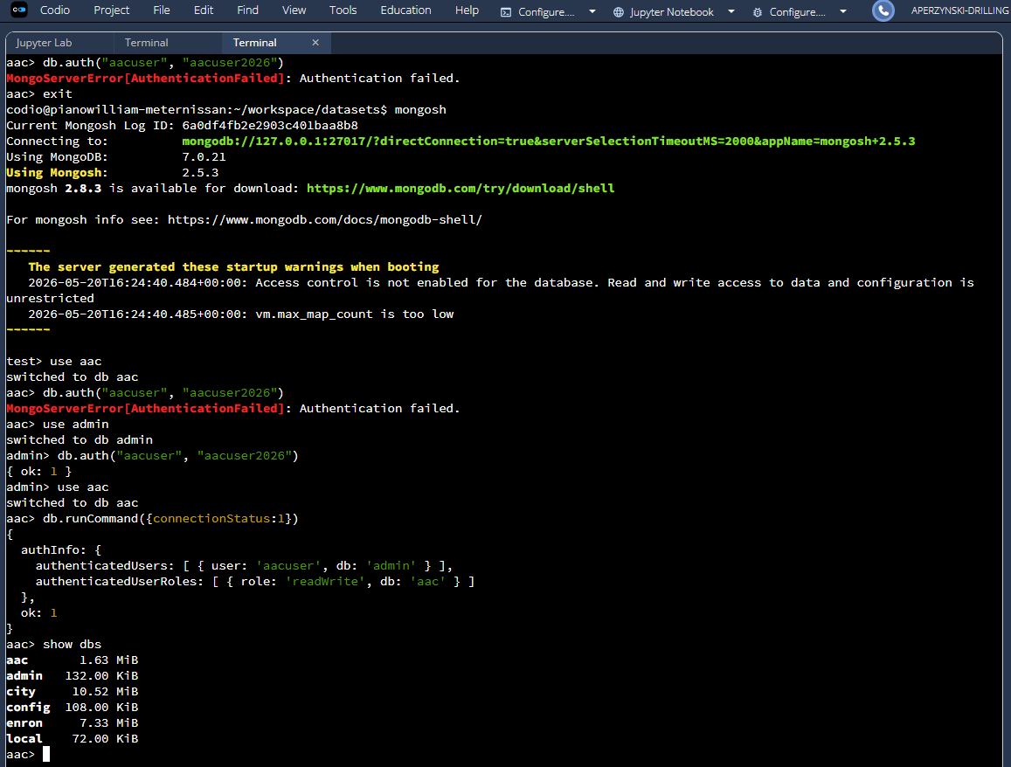

- Open Jupyter Lab.
- Import the CRUD_Python_Module.py file into the code_files directory
  - NOTE: Be sure to update the HOST, PORT, DB, and COL variables of the CRUD object to your respective MongoDB environment.
  - This file contains the CRUD operations written in Python necessary to manage the database.
    - By looking into this file, you will find the Python methods for Create and Read. The comments should explain the logic.
To use the CRUD_Python_Module:
- Create a new .ipynb notebook file and import CRUD_Python_Module.
  - Ex ) from CRUD_Python_Module import Animal Shelter
- Instantiate the CRUD class with the user credentials you set up in step 7:
- Ex) shelter = AnimalShelter("username", "password")
To use the Fetch&Rescue dashboard:
- Import the ProjectTwoDashboard.ipynb file into the code_files directory.
  - Open the file and update the Data Manipulation / Model section with your username, password, HOST, PORT, DB, and COL variables of the CRUD object to your respective MongoDB environment.
- Run the ProjectTwoDashboard.ipynb file and click the external link at the bottom to open the dashboard. The dashboard should open in a new window:

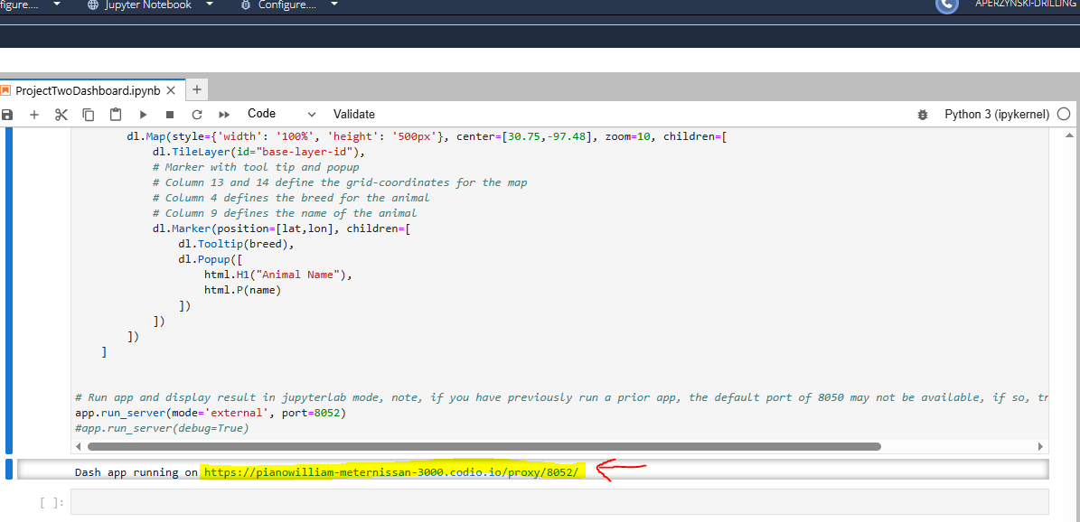

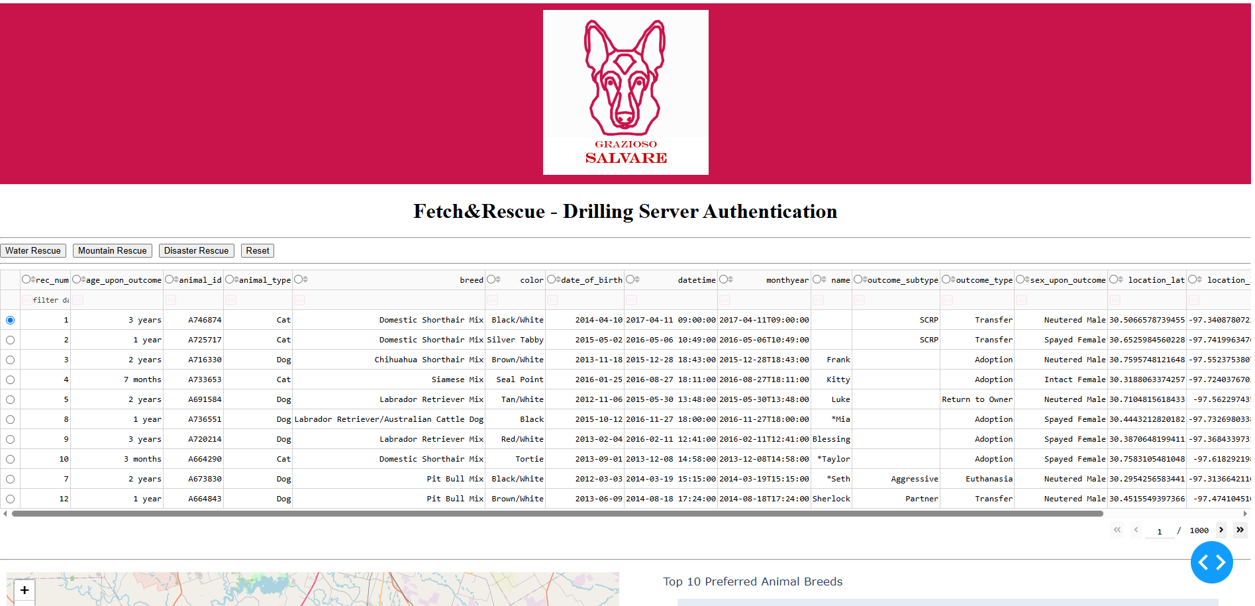

Installation
The following tools are necessary for the Fetch&Rescue application:
- MongoDB v7.0.21
  - MongoDB Installation Tutorials
  - Justification: The database that stores animal shelter records, allowing for complex and varied animal profiles without the need for rigid database migrations. The official PyMongo library allows developers to write native Python code to query the database, further removing the need for complex SQL strings or relational tables. Additionally, query results are returned as dictionaries, which can be passed directly to a Pandas DataFrame.
- Mongo shell v2.5.3
  - Install mongosh
  - Justification: The administrative terminal used to directly interact with, query, and verify the raw database structures and data types.
- Python v3.13.2
  - Download Python
  - Libraries:
    - MongoClient
    - ObjectId
    - PyMongoError
  - Justification: The programming language used to build the logic, control structures, and reusable CRUD class that automates data handling.
- PyMongo v4.13.2
  - Installing / Upgrading - PyMongo 4.13.2 documentation
  - Justification: The driver/bridge that allows the Python code to communicate natively with the MongoDB server.
- Jupyter Lab v3.6.3
  - Installation — JupyterLab 3.6.8 documentation
  - Justification: The development environment is used to visually test, run, and demonstrate Python modules and verify their output.
- Dash v2.8.1
  - https://plotly.com/dash
  - Justification: The Python framework that provides native support for advanced callbacks and interactive data components, such as tables, charts, and graphs.
- jupyter_dash v0.4.2
  - https://github.com/plotly/jupyter-dash
  - Justification: Allows real-time development and debugging of Dash applications directly inside Jupyter notebook environments without disrupting the workflow or conflicting with the backend server.
- aac_shelter_outvome.csv dataset
  - Justification: The dataset is required to fill the database.
- CRUD_Python_Module.py
  - Justification: The reusable modules handle CRUD operations.
- ProjectTwoDashboard.ipynb
  - Justification: The client-facing web application dashboard that provides a user-friendly interface to interact with and visualize data from the animal shelter database, reducing user errors and training time.
- ProjectOneTestScript.ipynb (optional)
  - Justification: A test script for the CRUD operations.

Using the CRUD Module
As of 6/7/2026, the CRUD_Python_Module supports Create, Read, Update, and Delete operations on database documents.

NOTE: You must import the CRUD_Python_Module to use the CRUD functions.

Code Example

Create a new database record

shelter = AnimalShelter(“username”, “password”)
new_record = shelter.create(document)

## OPTIONAL: Print new_records to see if the insert was successful. If successful, True should be printed

Print(“Insert Successful: ” new_record)

Sneak peek into the method code:
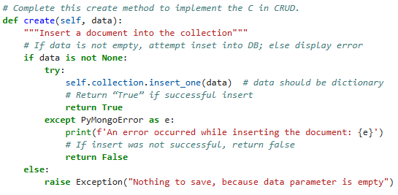
Read all database records

shelter = AnimalShelter(“username”, “password”)
query = {“breed” : “Domestic Shorthair Mix”} # Mongosh query the desired documents

found_docs = shelter.read(query) # use the read methods on the shelter instance with the query as the argument

## OPTIONAL: Print found_docs to see all the documents found. If successful, a list will be printed.

Print(“Read Successful: ” found_docs)

Sneak peek into the method code:

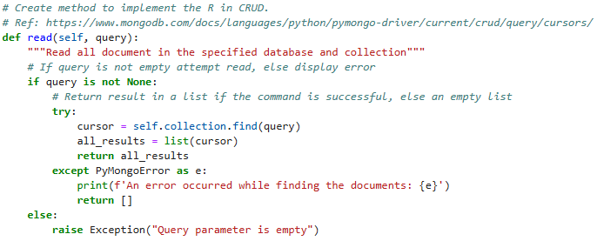
Update database record(s)

shelter = AnimalShelter(“username”, “password”)
new_data = {"age_upon_outcome" : "5 years"} # New data to be updated in doc

# Update the document by specifying the document(s) to query and data to update it with.
modified_count = shelter.update(document, new_data) # Store count

print("Update successful: Documents modified (Expected 1) - ", modified_count)

## OPTIONAL: Confirm the update by using the read function

# Declare query to confirm update
my_animal = {
"animal_id" : "ABPD23",
}
# Find the documents and report results
updated_docs = shelter.read(my_animal)
print("Read successful:", updated_docs)

Sneak peek into the method code:

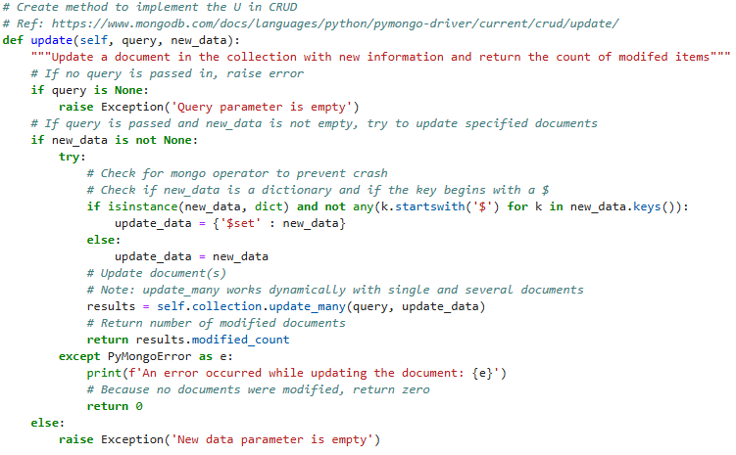
Update database record(s)

shelter = AnimalShelter(“username”, “password”)

# Declare query to find the document to delete
my_animal = {
"animal_id" : "ABPD23",
}

deleted_count = shelter.delete(my_animal) # delete document and return count
print("Delete successful: Documents deleted (Expected 1) - ", deleted_count)

## OPTIONAL: Confirm the update by using the read function

# Find the documents and print results
updated_docs = shelter.read(my_animal)
print("Read successful (expected []):", updated_docs)

Sneak peek into the method code:

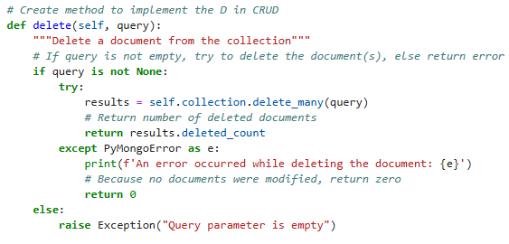

Tests
To test the methods within the module, open a new .ipynb notebook within Jupyter Lab.
- Within the first cell, import the CRUD module.
- In the second cell, instantiate an instance of the class using user credentials.
  - Refer to steps 10 and 11 in the Getting Started section.
- If creating a new record, in the next cell, create a document variable containing the new dataset information you wish to insert.
  - Use the create method call to insert the document defined in the document variable.
  - Optionally, print the results to see if the insert was successful.
- If reading a record, in the next cell, create a query variable containing the mongosh query with the information to query the desired documents.
  - Use the read method call to read the desired documents.
  - Optionally, print the results to see if the read was successful.
- If updating a record, in the next cell, create a new data variable containing the new data in mongosh format to use for updating the desired document(s).
  - Declare a variable document containing the query of the document to be changed.
  - Use the update method call with the document query and new data to update the desired document(s) that fit the query criteria.
    - When printed, the update call will display the modified count.
  - Optionally, print the read results or the to see if the insert was successful.
- If deleting a record, in the next cell, declare a query variable containing the mongosh query to find the documents that will be deleted.
  - Use the delete method call with the document query to delete all documents that fit the query criteria.
    - When printed, the delete call will display the deleted count.
  - Optionally, print the read results or the to see if the delete was successful.
- Run the test script using the run button at the top of the screen or by using shift + enter on each cell
  - NOTE: The module must be imported first before the methods can be used.

Screenshots
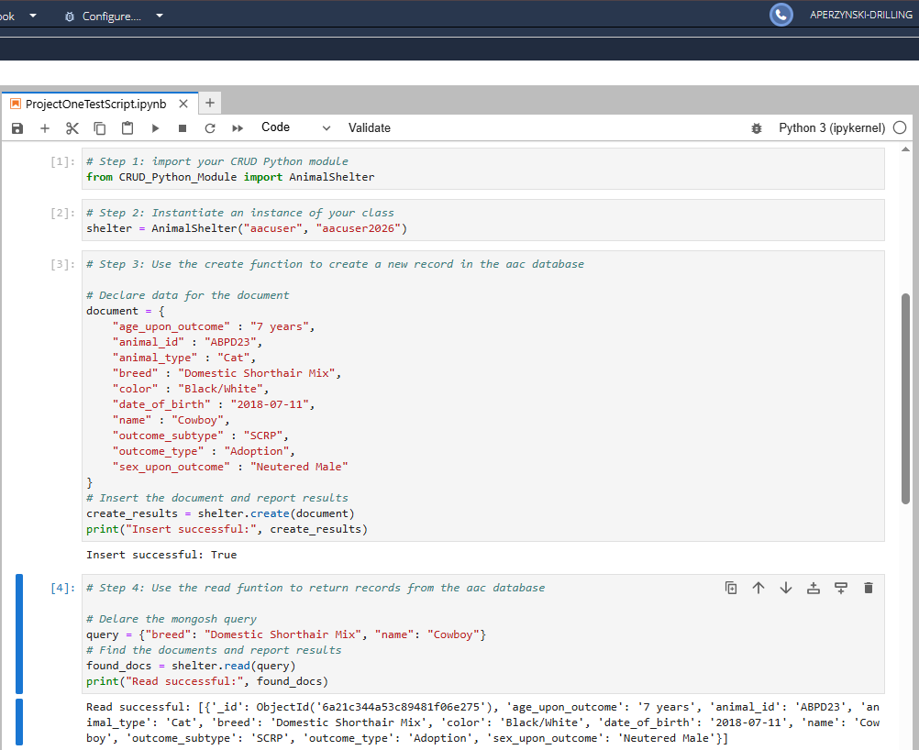

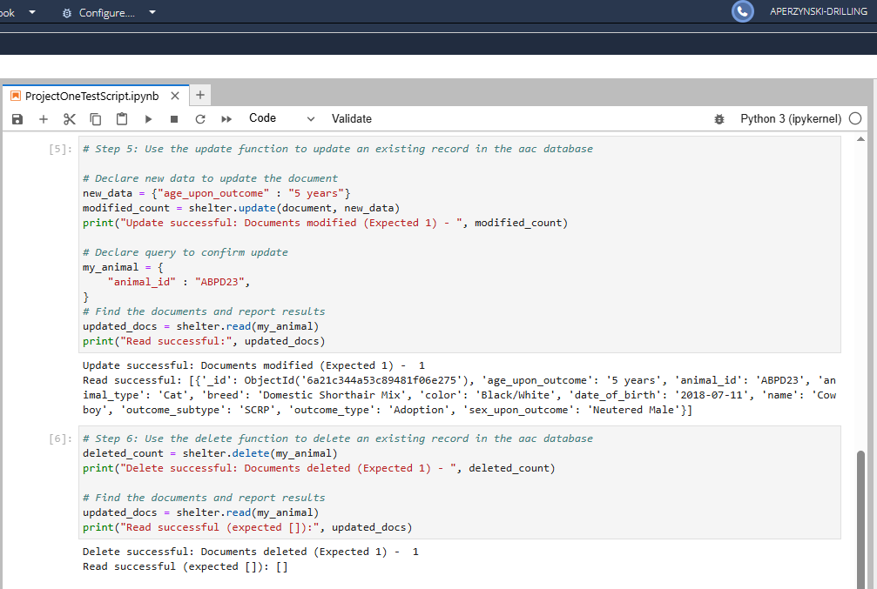

Using the Fetch&Rescue Dashboard
As of 6/21/2026, the Fetch&Rescue dashboard is a read-only application that organizes data from the shelter database into a table, map, and bar graph.
The web application is built on a dash framework that serves as both the View and Controller components of the Model-View-Controller architecture, bridging the backend (MongoDB) and the user.

Code Example
- The Data Manipulation / Model
  - Handles the data, database operations, and business logic. In other words, this layer initializes the interactions between the CRUD_Python_Module and MongoDB. It responds to requests from the controller and updates its own data state.

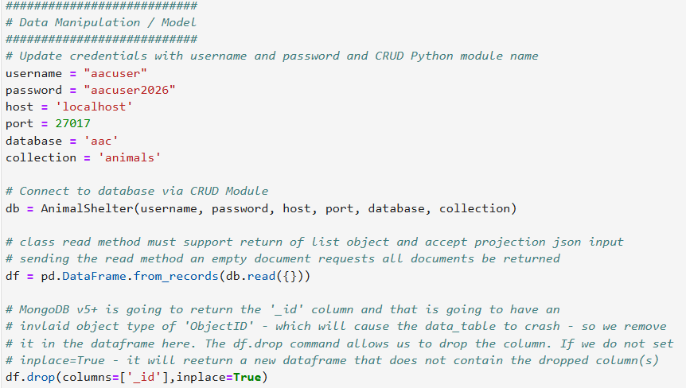
- The Dashboard Layout / View
  - The user interface (UI)— what the user will see on the screen. It displays data to the user based on information received from the model (usually via the controller) and accepts user inputs.
  - In Fetch&Rescue, the view component is written in Python using Dash HTML and Dash Core components. These components consist of:
    - The brand header hosting the Grazioso Salvare logo,
    - The preset filter buttons for specialized rescue operations,
    - The data table that renders the raw MongoDB data,
    - The geospatial map,
    - And the bar graph.

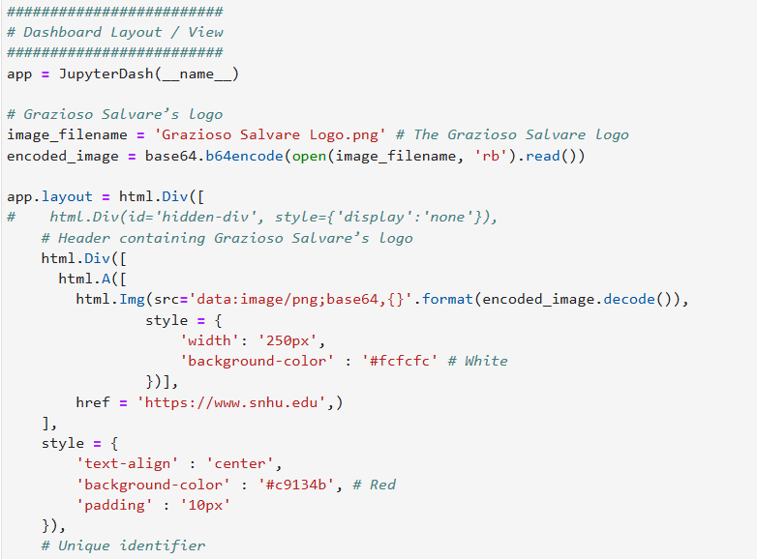
- The Controller
  - The "brain" of the application. It takes user input, applies the logic, and tells the Model and View how to respond.
  - This structure is powered by Python Callbacks.
  - The Controller manages three major components:
    - The data filtering callback
      - The controller listens for a click input on the filtering buttons. Using callback context (ctx), it determines which button was pressed via button ID and fetches the records using the appropriate Mongo query, powered by the CRUD module. Then, it updates the view of the data table.
    - The dynamic chart callback
      - The controller monitors the state of the data table. Whenever a filter is applied, the controller automatically recalculates the count of dog breeds and redraws the Plotly bar graph in real time.
    - The geolocation map callback
      - The controller for a row selection event on the data table. When a user selects a specific animal record row, the controller extracts the latitude and longitude coordinates and updates the map marker to display the animal's location, name, and breed.

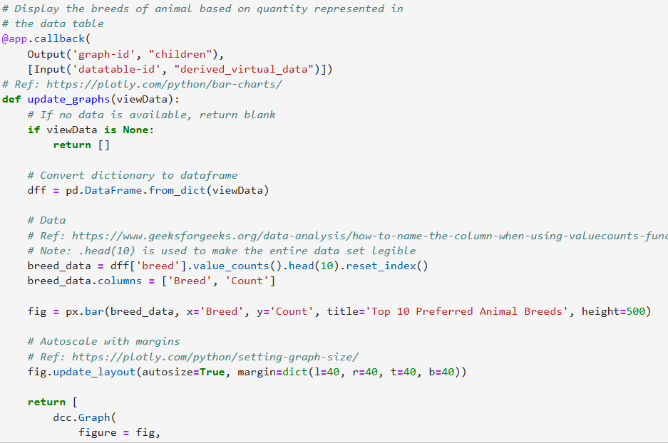

Troubleshooting
When launching the Dash or JupyterDash application, encountering a “Port already in use” error is very common. This happens when a previous instance of the app is still running in the background, or when another local service has claimed that network port.
If you encounter this error, follow these basic troubleshooting tests to resolve the issue:
  - Change the port number in Python
    - The easiest way to bypass a blocked port is to run the application on an alternative port number, such as 8051, 8052, etc.
    - Modify the last line of code in the ProjectTwoDashboard.ipynb file to a different port:

app.run_server(mode='external', port=Your New Port Number)
    - Run the application again.
  - Restart the Jupyter Kernel
    - If you are developing inside JupyterLab or Jupyter Notebook, rewriting code and executing the same cell will not automatically stop the previous server, which blocks the new code on the port.
    - At the top menu bar of the notebook interface, click the circular restart button to free the network port:

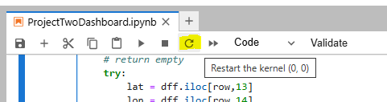

  - Locate and Kill the Process via Terminal
    - If restarting the notebook kernel does not release the network port, a ghost process may still be running on the operating system.
    - Open the environment terminal or command prompt and run the following commands:
      - Linux:
        - Find the process ID (PID) listening to the port:
          - lsof -i :<PORT_NUMBER>
        - Look at the PID column in the output and terminiate it using that number:
          - kill -9 <PID_NUMBER>
      - Windows:
        - Find the process ID listening to the port:
          - netstat -ano | findstr :<PORT_NUMBER>
          - taskkill /PID <PID_NUMBER> /F

Dashboard Demo

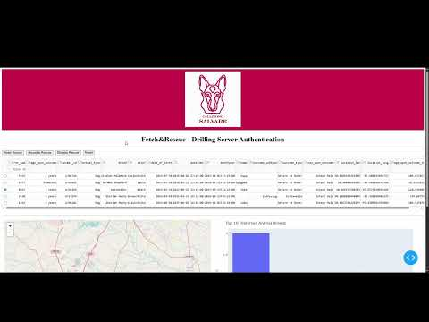

Roadmap/Features (Optional)
Planned features and releases (subject to change):
- 6/7/2026: Create Update and Delete methods
- 6/7/2026: Create test script for all CRUD methods
- 6/7/2026: Begin work on dashboard authentication
- 6/14/2026: Create geolocation chart within dashboard
- 6/21/2026: Release Web Application Dashboard

Contact
Anyka Perzynski-Drilling: anyka.perzynski-drilling@snhu.edu

